
Name of Student: Advait Dhanawade | PRN: 25070122023
Subject: Programming with Java
ASSIGNMENT No: 4
TITLE: Develop a Java application demonstrating the use of wrapper classes for conversion between primitive data types and objects, and performing basic operations on wrapped values.

Problem Statement
Develop a Java application demonstrating the use of wrapper classes for conversion between primitive data types and objects, and performing basic operations on wrapped values.
Learning Objectives
To perform conversion between primitive data types and wrapper objects using Java wrapper classes.
Theory
Wrapper classes are predefined classes that encapsulate primitive data types into objects. Java provides wrapper classes such as Integer, Double, Character, and Boolean for every primitive type. They support autoboxing, unboxing, parsing, and conversion methods. Wrapper classes are widely used in Java Collections Framework and when object representation of primitive values is required.
Exercise
1.Create a program to convert student marks from String format to Integer and calculate total marks.
package Assignment4;

//========== Student Marks Wrapper ==========

public class exercise1 {
public static void main(String[] args) {

System.out.println("--- Student Marks ---\n");

//marks as String
String mark1Str = "67";
String mark2Str = "98";
String mark3Str = "78";

//convert to Integer
Integer mark1 = Integer.parseInt(mark1Str);
Integer mark2 = Integer.parseInt(mark2Str);
Integer mark3 = Integer.parseInt(mark3Str);

int totalMarks = mark1 + mark2 + mark3;

System.out.println("CAO Marks:\t" + mark1);
System.out.println("LA Marks:\t" + mark2);
System.out.println("PP Marks:\t" + mark3);
System.out.println("-------------------------");
System.out.println("Total Marks:\t" + totalMarks);
}
}

Output
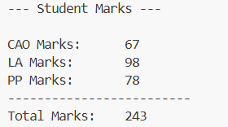
2. Develop an Employee Payroll System that accepts employee IDs, basic salary, and bonus amounts from the user. Convert the entered values into wrapper objects and perform validation operations to ensure valid salary values before calculating the net salary.
package Assignment4;

import java.util.Scanner; //Scanner class for input

public class exercise2{
public static void main(String[] args) {

Scanner input = new Scanner(System.in);
System.out.println("--- Employee Payroll System ---\n");

//String inputs
System.out.print("Enter Employee ID: ");
String empIDString = input.nextLine();
System.out.print("Enter Basic Salary: ");
String salaryString = input.nextLine();
System.out.print("Enter Bonus Amount: ");
String bonusString = input.nextLine();

//Wrappers
Integer empID = Integer.valueOf(empIDString);
Double basicSalary = Double.valueOf(salaryString);
Double bonus = Double.valueOf(bonusString);

//Salary Validation
if (basicSalary <= 0) {
System.out.println("\n!ERROR: Invalid salary value! Basic salary must be greater than 0.");
}
else {
//Calculate Net Salary
Double netSalary = basicSalary + bonus;

//Display Payroll
System.out.println("\n _______________________________");
System.out.println("|-------Payroll Details---------|");
System.out.println("|Employee ID :" + empID + "\t\t|");
System.out.println("|Basic Salary :Rs." + basicSalary + "\t|");
System.out.println("|Bonus :Rs." + bonus + "\t|");
System.out.println("|-------------------------------|");
System.out.println("|Net Salary :Rs." + netSalary+ "\t|");
System.out.println("|_______________________________|");
}

//Close Scanner
input.close();
}
}

Output:
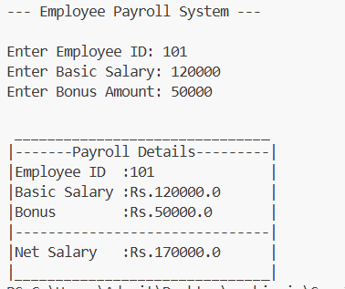

Conclusion: We have successfully implemented application-specific Java programs to perform conversion between primitive data types and wrapper objects using wrapper classes.

